**Lab 2: Data Carving**

**What You Need for this lab**

* + Install Virtualbox : <https://www.virtualbox.org/wiki/Downloads>
  + Install Kali 2021.4. : <https://old.kali.org/kali-images/kali-2021.4/>
    - Notes: Suggest You configure the disk size of Kali VM 80G because the size of each leakage cases image is 30G+
  + Run a tool installation script instructions, or you can simply follow the commands below : ( the script ONLY is tested on Kali 2021.4 )
  + wget https://raw.githubusercontent.com/frankwxu/digital-forensics-lab/main/Help/tool-install-zsh.sh
  + chmod +x tool-install-zsh.sh
  + ./tool-install-zsh.sh

**Example scenarios**

* Scenario 1: A file (A) is hidden inside of another file (B). You can’t open the file B because the B’s header is corrupted.
* Scenario 2: A suspect deleted files. The files contains an important information. A file occupies a few clusters. Unfortunately, some clusters are reused (overwritten) by new files.

A forensic expert really wants to recover files, even a partial files.

1. **Extracting images from a corrupted Word document**

**Step 1.**

* Prepare required files

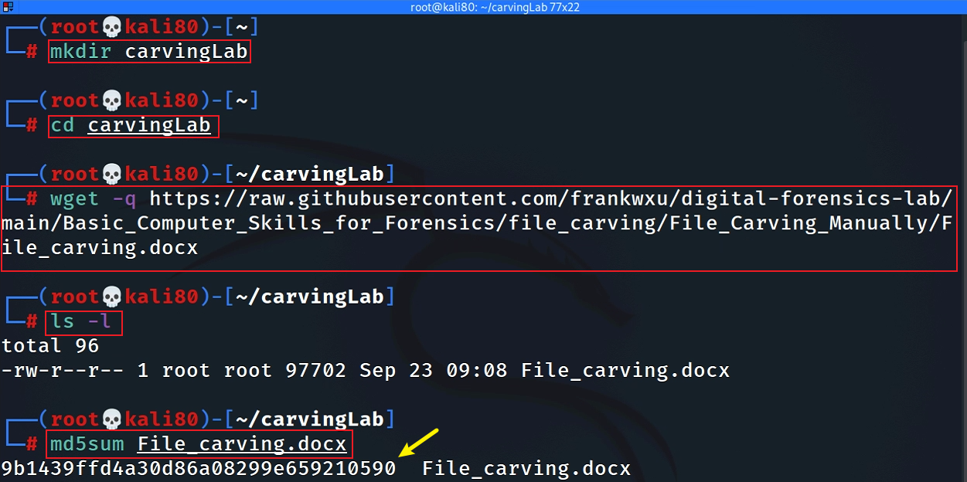

**Step 2.**

* View the file in a hex editor

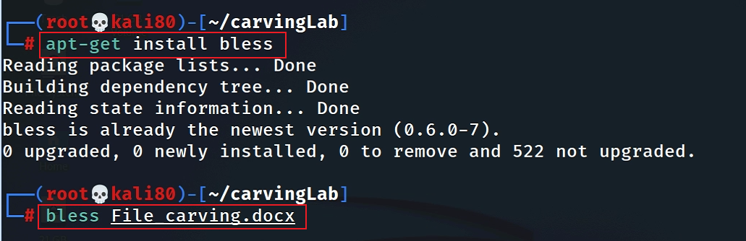

**Step 3.**

* Search file header start offset – 0F5E

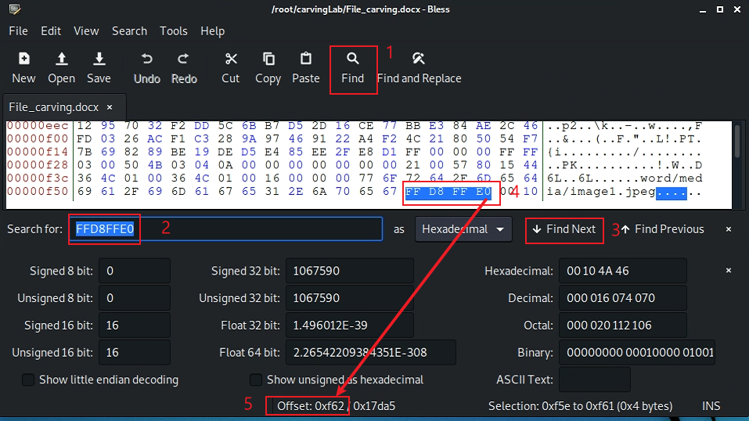

* Search file trailer ends offset – 15B93

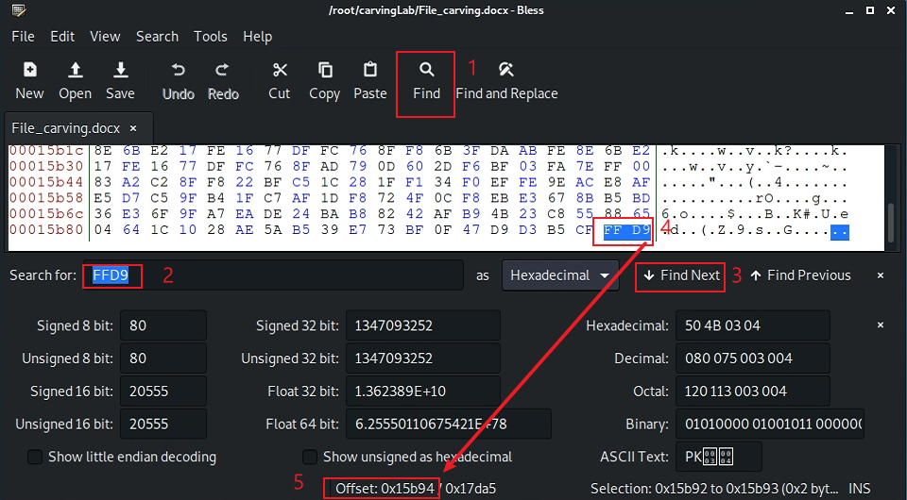

* Select hex from header to tail
* (0F5E)16=(3934)10
* (15B93)16=(88979)10

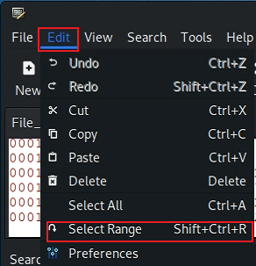

* Copy the selection

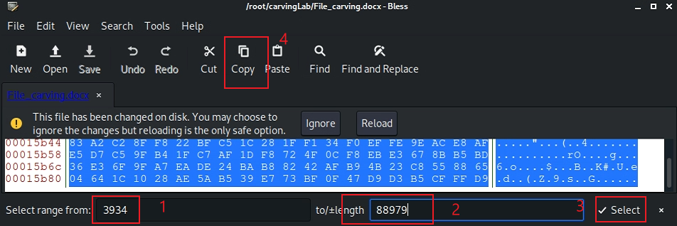

* Paste the selection

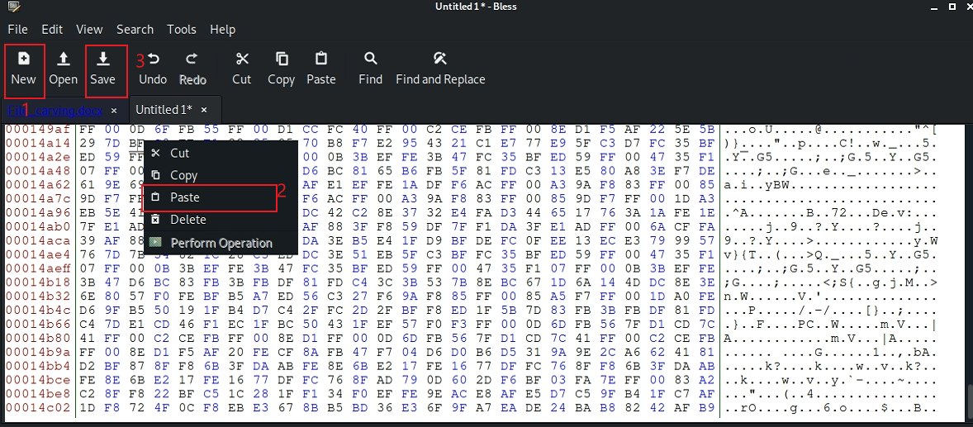

* Save the image

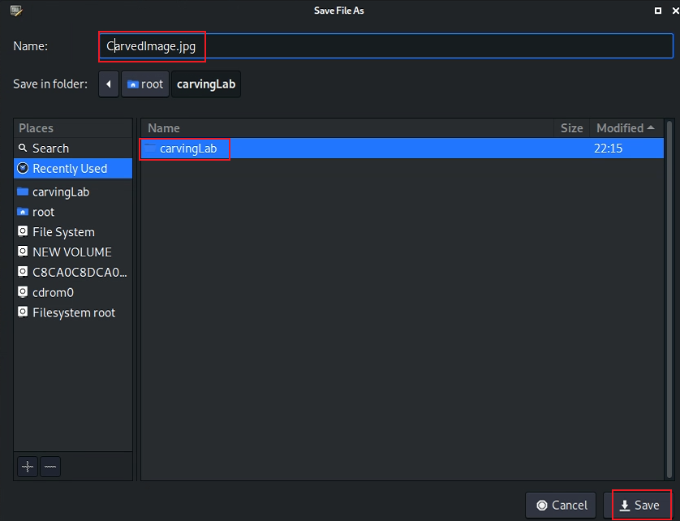

**Step 4.**

* Show the carved image

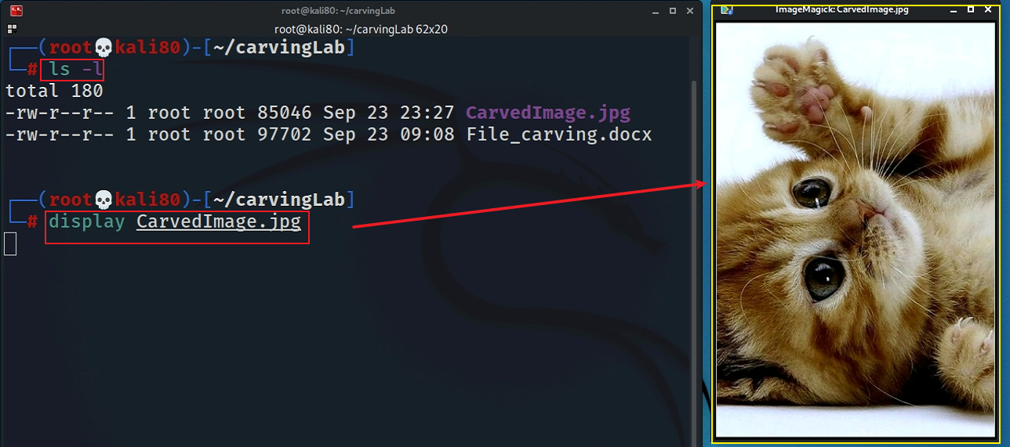

1. **Carving/Recovering a USB image**

* Prepare a USB image for file carving

**Step 1.**

* Download the zipped USB image

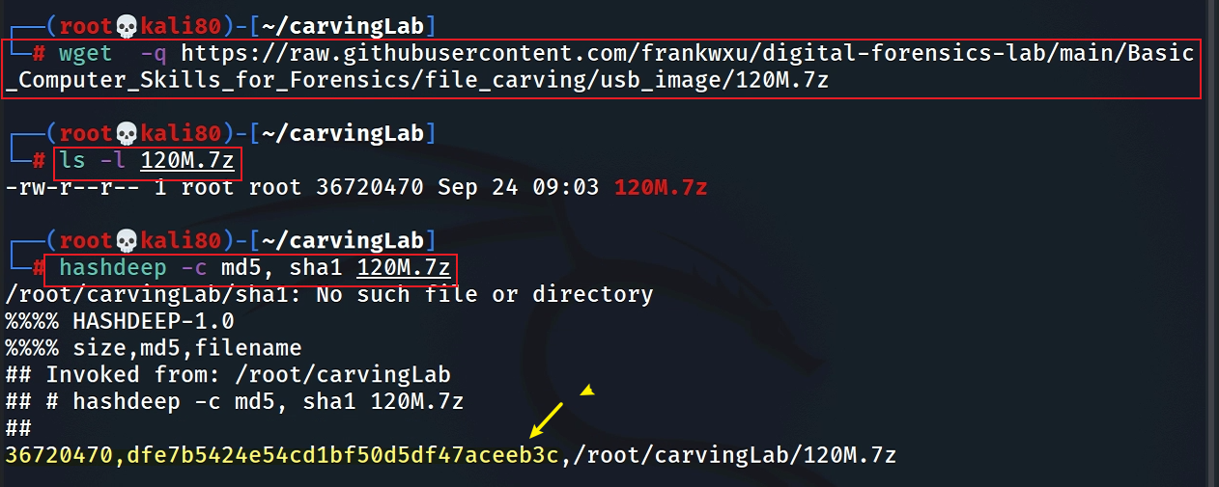

* Compute hashes

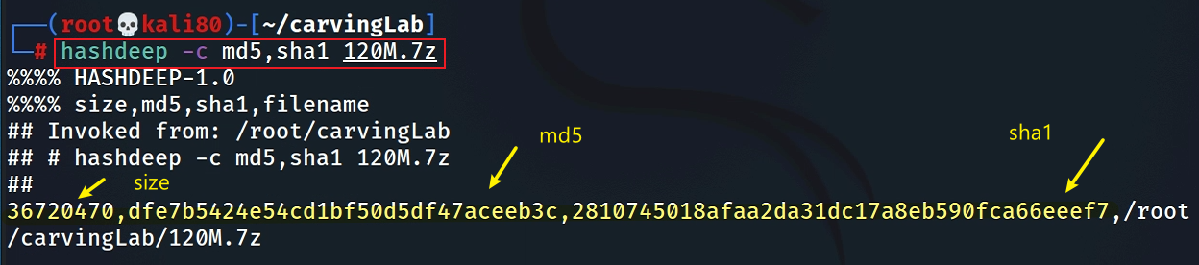

* List the content of the zipped file

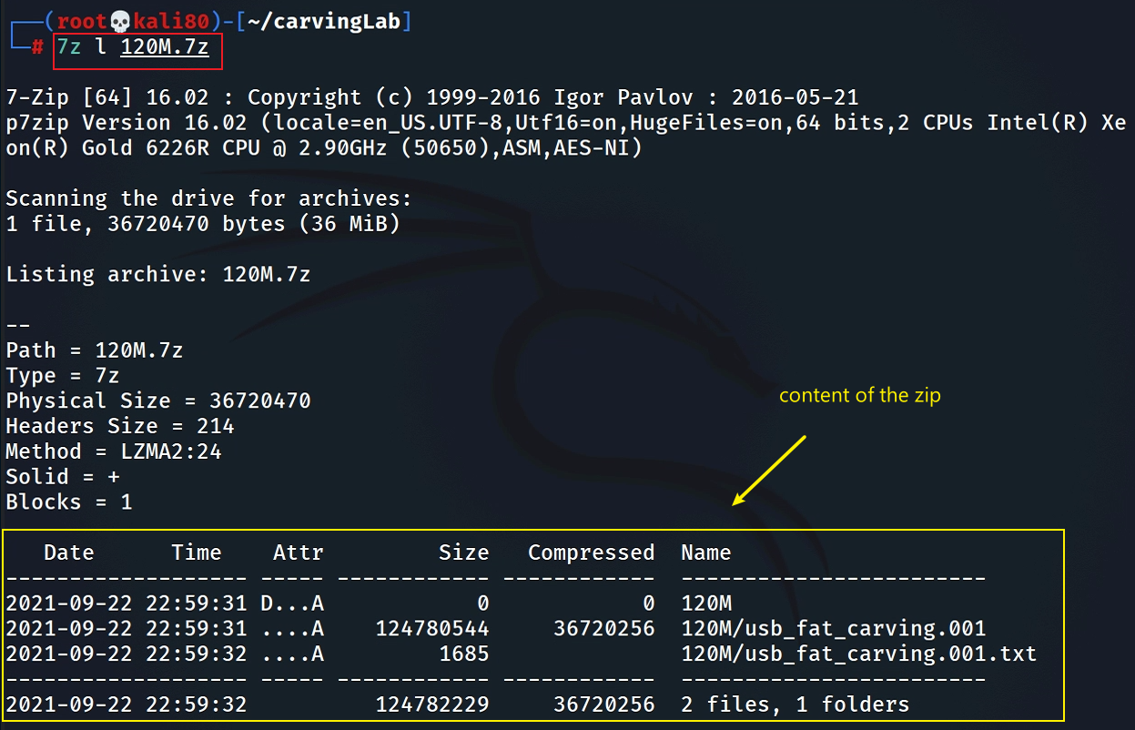

* List the content of the zipped file

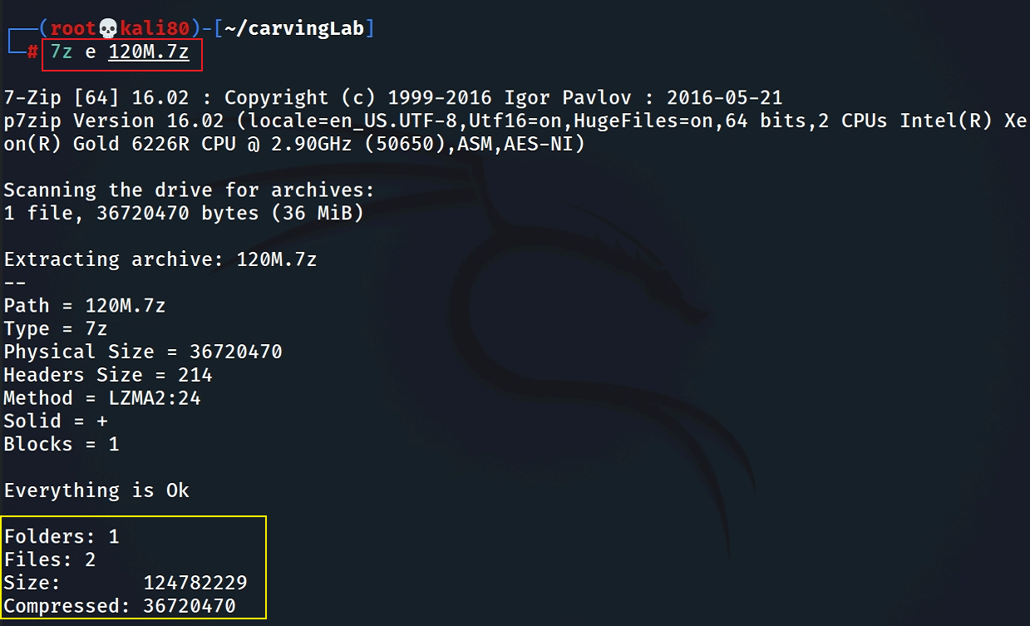

* Verify the hashes

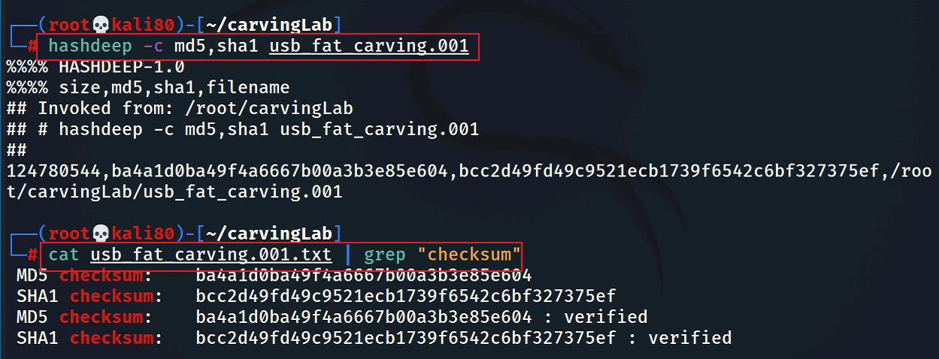

**Step 2.**

* Exam the content of the USB
* Display partitions

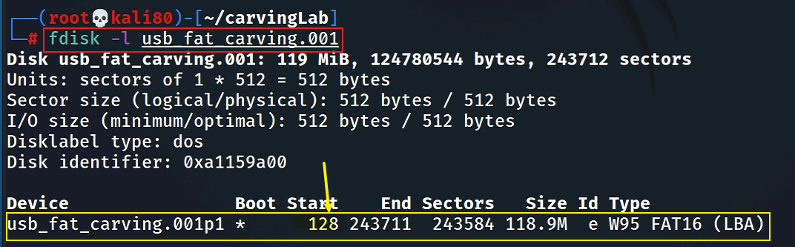

* Find deleted files

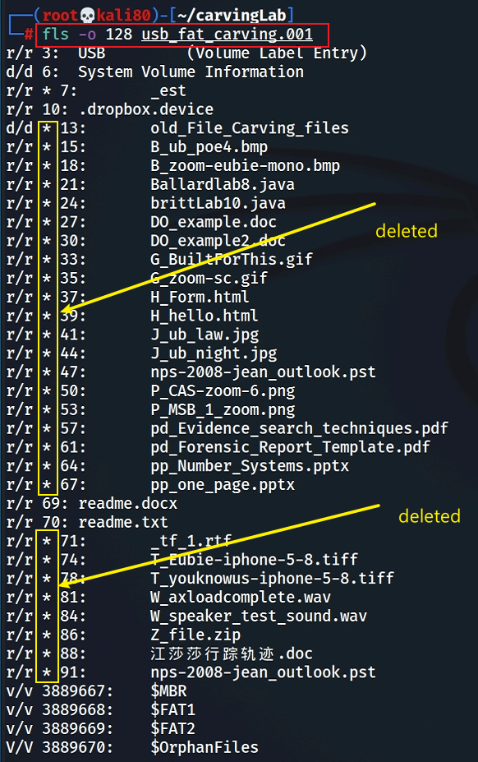

* Decide which file types need to carve

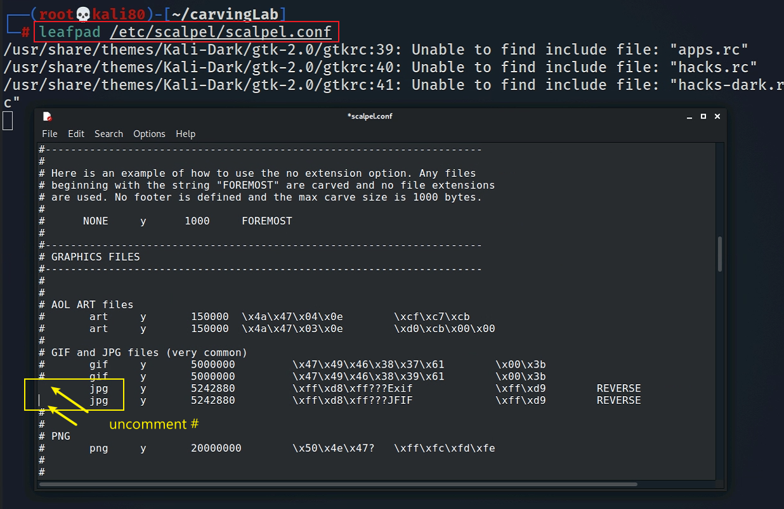

* Save it and quit!
* Show help

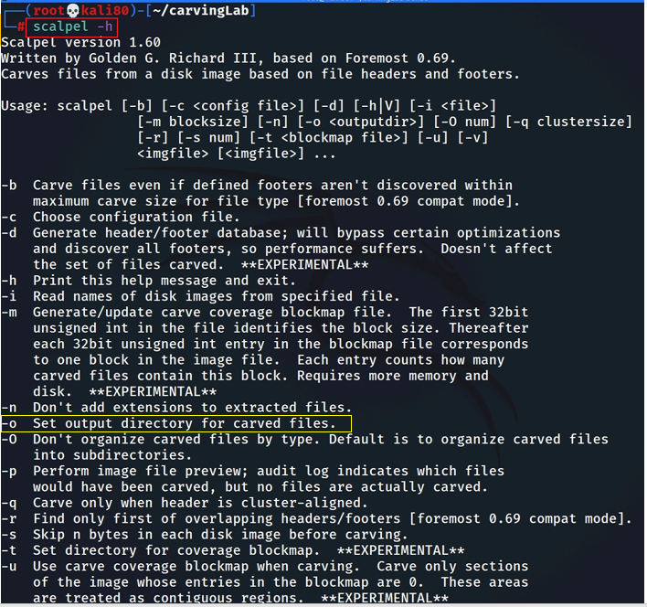

**Step 3.**

* Carving the USB image

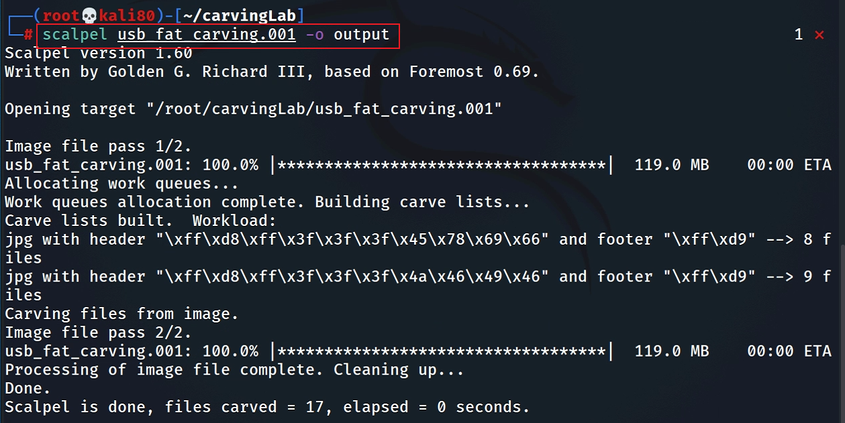

* Show carved files

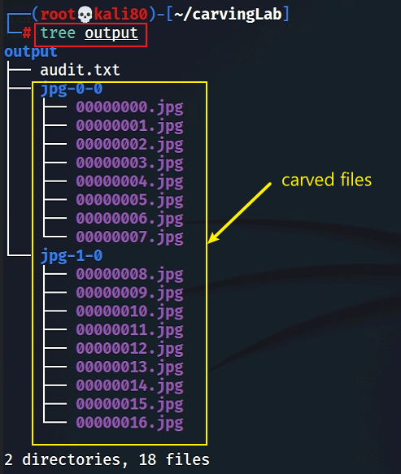

* Show audit log

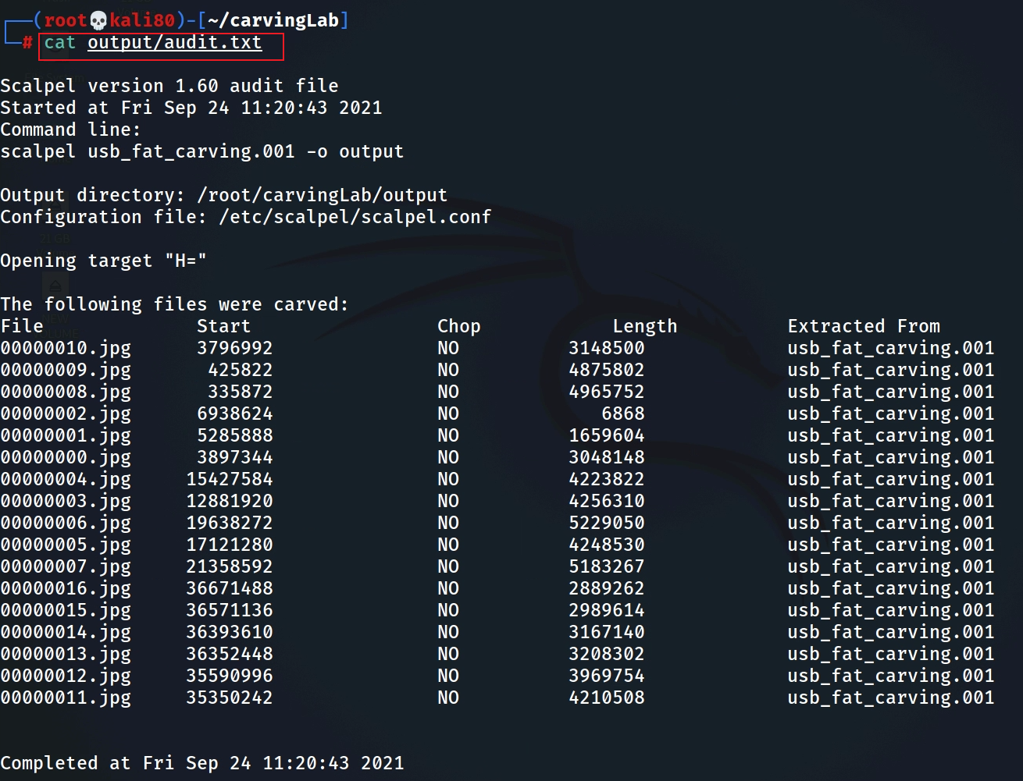

**Step 4.**

* Display two carved jpg image

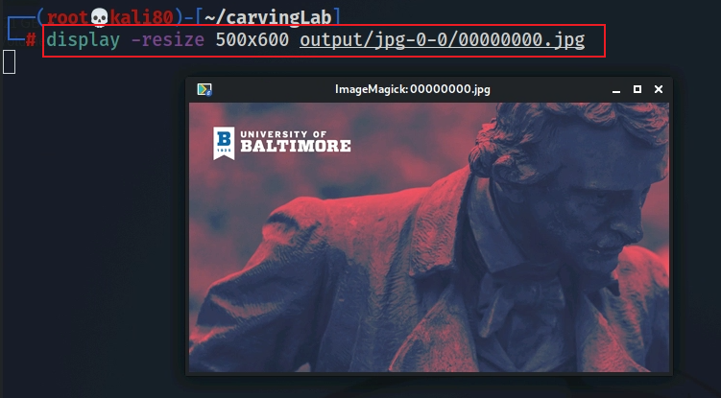

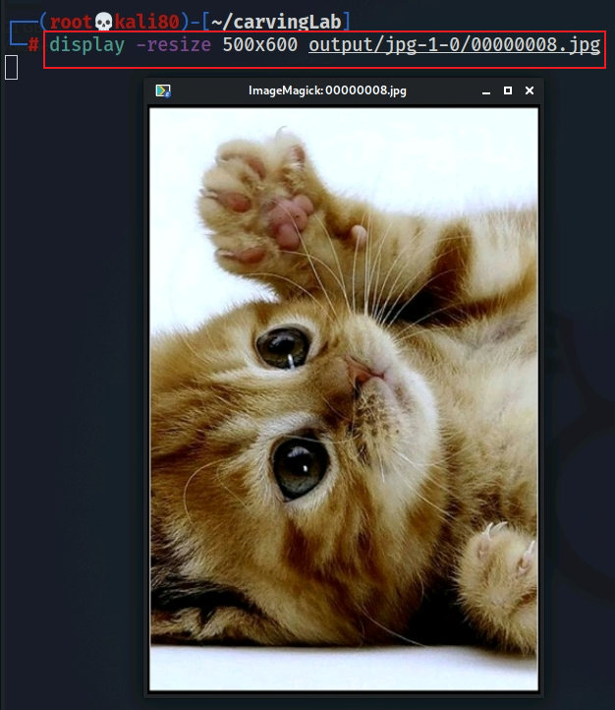

**YOU MUST SUBMIT A FULL-SCREEN IMAGE FOR FULL CREDIT!**

Save the document with the filename "**YOUR NAME Lab 2.pdf**", replacing "YOUR NAME" with your real name.

Email the image to the instructor as an attachment to an e-mail message. Send it to: **xxx@fe.edu.vn** with a subject line of "**Lab 2 From YOUR NAME**", replacing "YOUR NAME" with your real name.